**Evaluating Management Strategies for Atlantic Bluefin Tuna**

***Report 6: Updated operating model, MSE package, CMPs.***

February 19th 2019

SHORT-TERM CONTRACT FOR MODELLING APPROACHES: SUPPORT TO BFT

ASSESSMENT (GBYP 07/2018) OF THE ATLANTIC-WIDE RESEARCH PROGRAMME ON

BLUEFIN TUNA (ICCAT-GBYP – Phase 8)

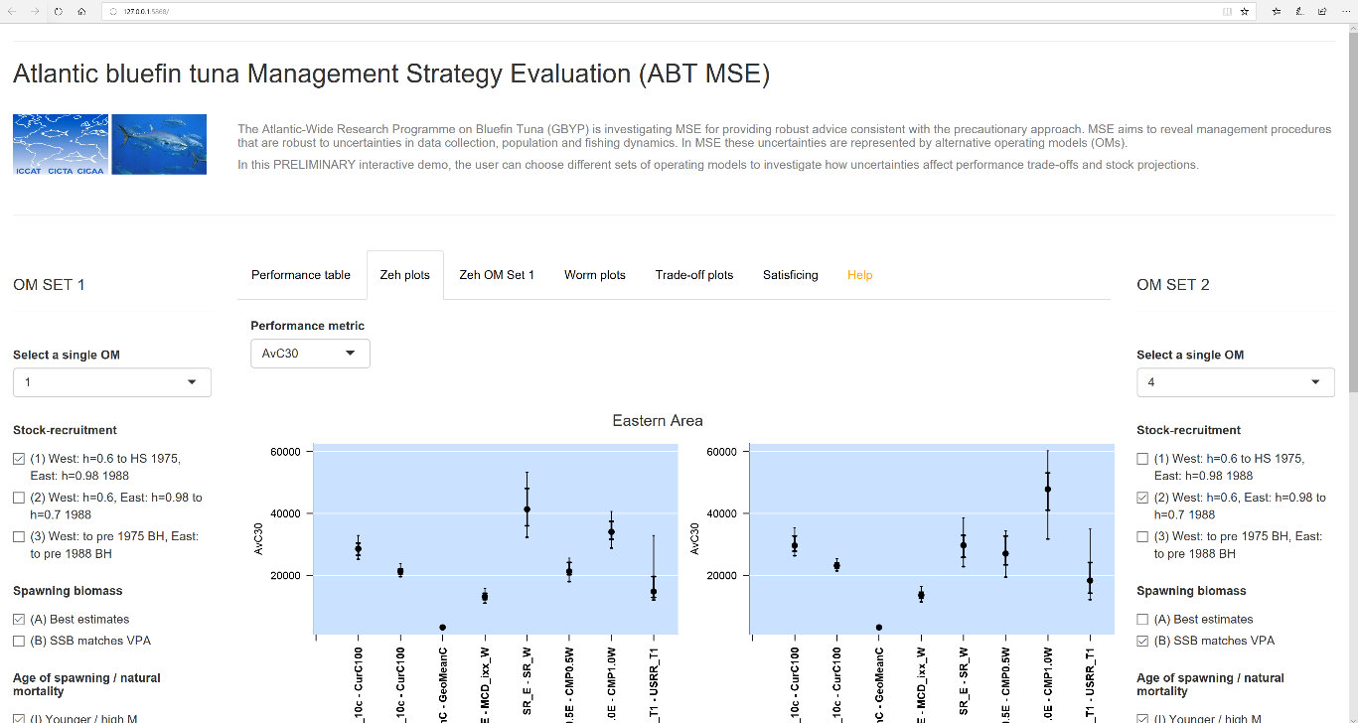

*Preliminary Shiny App*

Tom Carruthers[1]

**Executive Summary**

The focus of this contract was to take the first fully documented MSE framework (ABT-MSE v2.3.0) and refine it to account for feedback from the 2018 Swordfish and Bluefin tuna MSE meeting and the 2018 bluefin species group meeting.

Tasks

- Refine the software package following feedback from users at the 2018 ICCAT Bluefin Tuna and North Atlantic Swordfish MSE Meeting. Operating models have been updated considerably to include, for example, multiple phases of recruitment estimation and time-varying future movement (now version v4.4.5).

- Maintain the [meta-data base](https://drive.google.com/open?id=140HrddEWU_MFHhxizVtaO_uRs48tzPrEgbDMwudl_1M). This has been updated to v3.0 (February 2019)

- Continue to develop help-documentation and tutorials to assist stakeholders in CMP development. A dedicated CMP developers guide [now available](https://drive.google.com/open?id=1QCwUQhqfmTRa8TqJNWIoOhmg8n1Urf6L) is now available.

- Work with stakeholders to assist them to develop CMPs, and also the Contractor himself is to develop a CMP. A multi-stock mixing CMP, ‘MPx’ was presented to the group and is included in the latest R package (Carruthers 2018, Appendix 1). In the February 2019 MSE workshop, more than 13 CMPs were integrated into the R package.

- Produce MSE visualization tools such as a revised Shiny App and Bayesian Belief network. Reference set operating models were not finalized during this contract and visualization tools could therefore not be updated. However, computer code was written to largely automate this process given an agreed set of operating models.

- Produce a scientific manuscript on a multi-stock management procedure to be presented as scientific communication to the ICCAT SCRS Species Groups 2018 meeting (as above the development of ‘MPx’, Carruthers 2018, Appendix 1).

- Produce a scientific manuscript on ‘Strategies and Tactics in the Campaign for Sustainability of Atlantic Bluefin Tuna to be presented as scientific communication to ICCAT SCRS Species Groups 2018 meeting. Although the scope of the paper and tentative authorship [has been proposed](https://docs.google.com/document/d/1a1K9kuBvZd-kfqX2hRnXwwdLkw1oHat1hJQpt4Z-EhM/edit?usp=sharing), without an agreed set of operating models it was not possible to describe the methods or obtain results). However, with the exception of the data-rich VPA MP (Table 1 linked document) all MPs are now coded and available for testing once the reference operating models are finalized.

- Assist in documenting the deliberations of meetings taking this MSE process forward in a manner that records developments in some detail. The latest Trial Specifications document (Appendix 2) has expanded considerably in scope to include comprehensive detail on all operating model aspects and now includes version numbering to record the evolution of decisions regarding operating model structure and assumptions.

Other products

- A mixture modelling approach was developed to more accurately process stock-of-origin data such as otolith microchemistry and genetics data (Carruthers and Butterworth 2018, Appendix 3).

- A full account of ABT-MSE v3.x.x operating models was submitted to the group (Carruthers and Butterworth 2018, Appendix 4)

- Following the identification of missing age-0 catches in the Mediterranean, a post-hoc analysis of impact on the Eastern VPA was conducted (Carruthers and Butterworth 2019, Appendix 5).

- An automatic report is not available in the ABTMSE R package (v4.x.x +) that standardizes MSE results.

Contents

1 Review of contract activities 2018 - 2019 4

1.1 Data preparatory meeting (March 6th – 11th) 4

1.2 Stock Assessment meeting (July 20th-28th) 4

1.3 Species group meetings (September 27th – 29th) 5

1.4 Developments since September 2017 5

2 Progress with respect to deliverables 6

3 Priorities for the MSE process 8

3.1 Software usability, support and debugging 8

3.2 Publish papers on MP development and testing 8

4 MSE development priorities 8

4.1 Visualization tools 8

4.2 Data-rich MPs (major) 9

4.3 New observation error models for tagging data 9

5 References 9

6 Appendices 10

6.1 Appendix 1: Trial Specifications 10

6.2 Appendix 2: Meta Database 10

6.3 Appendix 3. SCRS papers. 10

6.4 Appendix 4: Complete R package for MP testing 11

11

6.5 Appendix 5: Standardized operating model reporting 11

6.6 Appendix 6: Draft peer-review paper on a Multi-stock, Multi-fleet, Multi-area MP 12

6.7 Appendix 7: Updated M3 user guide 12

6.8 Appendix 8: R package user guide 12

6.9 Appendix 9: Software design documents 13

# Review of contract activities 2018 - 2019

## Swordfish – Bluefin MSE meeting (April 2018)

The swordfish-bluefin tuna MSE meeting was convened to start the process of Candidate Management Procedure (CMP) development, agree on a standard for presenting results among CMPs, develop CMP tuning specifications, and discuss aspects where input from stakeholders will assist in future CMP development.

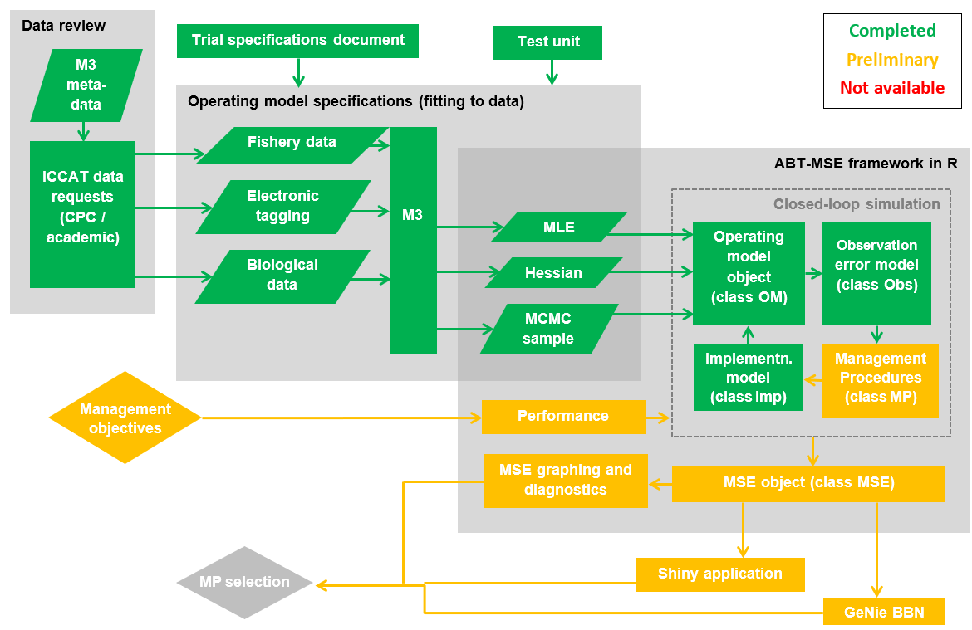

Figure 1. Current status of the components of the ABT MSE framework showing the preliminary nature of Management Procedures and Management objectives (and hence all components downstream).

## Bluefin Working Group meeting (September 2018).

The Bluefin Working Group convened to evaluate the progress on OM development, review approaches to interpret mixing data, establish terms for accepting / rejecting operating models, revise spatial OM structure if necessary and investigate the performance of existing CMPs. The meeting also included an initial discussion of OM plausibility weighting.

Two papers were presented on the mixture model and summarizing the current set of OMs.

## Bluefin MSE Technical Team and Working Group meeting (February 2019).

## Developments since September 2017

.

# Progress with respect to deliverables

|  |  |  |
| --- | --- | --- |
| **Deliverable 1 July 20, 2017 (100%)** | | |
|  | i | Workplan outlining the actions required to complete the final deliverables |
|  | ii | Presentation and short report summarizing current status of deliverables and actions required to achieve them |
|  |  |  |

1. The workplan was presented in [Progress Report 6](https://drive.google.com/open?id=1qTqupUrkDu0gHEmiUZMF8KnqQyDCYKKi)
2. This deliverable was addressed in [Progress Report 6](https://drive.google.com/open?id=1qTqupUrkDu0gHEmiUZMF8KnqQyDCYKKi) and accompanying presentations.

|  |  |  |
| --- | --- | --- |
| **Deliverable 2 September 23, 2017 (100%)** | | |
|  | i | Updated presentations and short report summarizing current status of deliverables and actions required to achieve them |
|  | ii | Examples based on agreed trials, to include output statistics and fully OM conditioning diagnostics |
|  | iii | Draft papers on application of MSE |
|  |  |  |

1. This was presented in [Progress Report 7](https://drive.google.com/open?id=1jGkMZUvG0SI_Z-BZ9iaZW9HM65bxE-5x).
2. Following feedback from Core Modelling Group at the Stock Assessment meeting, the [OM fitting reports](https://drive.google.com/open?id=1ppVm2mTsWjZsqtrl-RFQILsmO_OPNpJ0) were finalized in addition to a [new OM summary report](https://drive.google.com/open?id=1HCzvlkzVStkHZL-As7AOQgYHuQl3-2-C). The fits of the OM models were described in an SCRS paper ([2017/223](https://drive.google.com/open?id=1oJmXDD6tRKbEI4DwZnsLbFIAcq1EfiPt))
3. An SCRS paper ([2017/224](https://drive.google.com/open?id=1gauaI74rowuzY3pAE-qFFlWQuY9wElPI)) was produced documenting the MSE R framework being applied to a series of new management procedures

|  |  |  |  |
| --- | --- | --- | --- |
| **Deliverable 3 November 3, 2017 (100%)** | | | |
|  | i | Updated presentations and short report summarizing current status of deliverables and actions required to achieve them |
|  |  |  |

1. This was presented in [Progress Report 8](https://drive.google.com/open?id=1BeunZByTBxSCIgzIQsuO10MA4zMjjvVQ).

|  |  |  |
| --- | --- | --- |
| **Deliverable 4 February 21, 2018 (90%)** | | |
|  | i | Updated **Repository** with full tracking including version control for software development  <https://github.com/ICCAT/abft-mse> containing the OM |
|  | ii | Update of **SDP** (Software Development Plan) that will be reviewed by external experts, as agreed at Monterey meeting |
|  | iii | **Test Unit** so that code can be validated |
|  | iv | **Meta Database** summarizing all parameters and assumptions used  https://github.com/ICCAT/GBYP-MetaDB |
|  | v | Evaluation of **Management Procedures** implementation by 3rd parties.  Written up as SCRS papers and code available in repository |
|  |  |  |

1. The Repository was updated will the latest file structure that is also available from a Google Drive [here](https://drive.google.com/open?id=0B0TXcs-MLRl3c0w4VF9QbkJYOU0).
2. The Software Development Plan was revised to reflect the new phase of the MSE research in which collaborators will design and test their own MPs.
3. The test unit has been updated and rolled into the R package. It is described in [Section 9](https://drive.google.com/open?id=1tlNj3NZ1VXNwWq46dVKbqUTQgUI8Fp70) of the R Package User Guide.
4. The Meta Database has been updated and is available from a Google Drive [here](https://drive.google.com/open?id=140HrddEWU_MFHhxizVtaO_uRs48tzPrEgbDMwudl_1M). I do not have permission to upload this to the private ICCAT GitHub site at https://github.com/ICCAT/GBYP-MetaDB

**Current status of objectives**

|  |  |  |  |  |  |
| --- | --- | --- | --- | --- | --- |
| **Objective** | | | **Tasks (bold are completed)** | | |
|  | **i**  100% | Ensure the Operational Model (OM) implements the trials as specified by the 2016 CMG report. | | **Added (M3 v1.7):**  **age-based movement, plus group, model initialization at equilibrium estimated F, recruitment predicted from SSB in previous year, a prior for depletion to allow the model to fit specified depletion.** |
|  | **ii**  100% | Us the test unit to validate the age-based movement model | | **Now included in the R package for all users** |
|  | **iii**  50% | Work with third parties to add MPs to the MSE framework including empirical control rules and simple stock assessment methods | | In coordination with Doug Butterworth (CMG) and Paul de Bruyn (ICCAT) the R package and documentation (including a [covernote](https://drive.google.com/open?id=1eOq2vWoC-XjQf-884CYekrMU4SafVT7u)) has been circulated to prospective MP developers in Canada, USA, France, Morocco and Japan. |
|  | **iv**  50% | Run the MSE in collaboration with BFT Species group | | A demonstration MSE has been run and an SCRS paper describing preliminary results. However the intention of this Objective is presumably to summarize the results of MPs developed by stakeholders and as yet, none have been developed. |
|  | **v**  50% | Collaborate with the SCRS and others (e.g. rRFMOs) to develop interactive web based graphics to communicate MSE results to decision makers and stakeholders. | | The current [Shiny App](https://drive.google.com/open?id=1-xHUI02dwwv1g90c7c5dgAPbYOoMVh2d) (open server.R in RStudio and press ‘Run App’) serves as a demonstration of the type of online application that can be developed to explore and evaluate MPs. However since no MPs have been developed by stakeholders this App cannot yet be updated to reflect the latest MSE results. |
|  | **vi**  100% | Work with other to update and maintain the meta database of the available bluefin data and knowledge | | **The latest** [**meta database**](https://drive.google.com/open?id=140HrddEWU_MFHhxizVtaO_uRs48tzPrEgbDMwudl_1M) **(v2.0) has been made publically available and editable** |
|  |  |  | |  |

The objectives of this contract were compromised by delays in the finalization of the reference and robustness operating models. Once the Core Modelling Group decided that the operating models should reflect the 2017 stock assessments, the process was delayed by around 6 months. The earliest that operating models could then be finalized was after the September Species Group meeting that reviewed changes arising from the July Stock Assessment Meeting.

This movement in the MSE timeline has however not delayed the technical aspects of this contract which were under the remit of myself (the Technical Assistant). The ABT-MSE Package is now complete and ready for use by Stakeholders in the development and testing of Management Procedures. Additionally the decision to reflect the stock assessments provides two key advantages: (1) where possible the operating models reflect the latest and best available science for Atlantic bluefin tuna and (2) they can accommodate other scenarios for the robustness tests such as stock mixing scenarios and abundance index hyperstability.

# Priorities for the MSE process

## Software usability, support and debugging

The next phase of the MSE process will see stakeholders develop and test custom management procedures. Due to diversity in their skillset, background and experience each user is likely to require different levels and types of technical support. It is critical that user feedback is reflected in timely updates in the usability and features of the R ABT-MSE package, the supporting documentation and where necessary rapid fixing of any coding bugs that may be identified. The ICCAT GitHub repository offers an excellent forum for this feedback allowing for questions, desirable features and bugs to be reported in the ‘issues’ web page (<https://github.com/ICCAT/abft-mse/issues>).

## Publish papers on MP development and testing

In order to promote the work of stakeholders in developing management procedures it may be helpful to support or provide tools to aid in the production of SCRS papers documenting their research. This provides a transparent and citeable account of the project research that may also benefit other users.

# MSE development priorities

## Visualization tools

The current shiny app provides an early example of the type of outputs that can be produced to elicit feedback from a wider group of scientists and stakeholders that are less likely to participate in coding their own operating models and management procedures. Once the operating models are finalized (e.g. their fit is considered acceptable by the CMG) the Shiny App. should be updated to reflect the configuration and results of the latest MSE analyses (i.e. all 36 reference and 4 robustness operating models, searchable by hypothesis).

Although there appears to be a preference for presentation of MSE analyses by the Shiny App., it is straightforward to update the Genie Bayesian Belief Network. The BBN has additional value because it allows users to define and investigate custom utility functions which is much less straightforward in a Shiny App. This could be an alternative and invaluable tool for any bluefin MSE workshop.

It may be possible to link the visualization tools to standardized reporting of the user’s MSE exploration: for example, a .pdf report that consolidates the findings of any OM / MP specification.

## Data-rich MPs (major)

Many of the management procedures that are currently specified operate on few data or are simple stock assessments that do not account for process error. It would be desirable to develop MPs that represent current stock assessment for Atlantic bluefin stocks (a VPA) or those that can account for process error (e.g. a state-space delay-difference assessment).

## New observation error models for tagging data

Future MPs may wish to use data from tagging experiments to calculate management advice. It follows that observation error models may be required for conventional, PSAT, surgical electronic and genetic tags.

**Acknowledgments**

Many thanks in particular to Laurie Kell for technical support, Antonio di Natale and Paul de Bruyn for directing the project and Doug Butterworth for advancing the Trial Specifications document and his input on the SCRS papers.

This work was carried out under the provision of the ICCAT Atlantic-Wide Research Programme for Bluefin Tuna (GBYP), funded by the European Union, by several ICCAT CPCs, the ICCAT Secretariat and by other entities (see: http ://www.iccat.int/GBYP/en/Budget.htm). The content of this report does not necessarily reflect the point of view of ICCAT or of the other funders, which have no responsibility for it, neither does it necessarily reflect the views of the funders and in no way anticipates the Commission's future policy in this area.

# References

Carruthers, T.R., Butterworth, D.S. 2017a. Summary of a reference set of conditioned operating models for Atlantic bluefin tuna. Col. Vol. Sci. Pap. ICCAT. 2017/223.

Carruthers, T.R., Butterworth, D.S. 2017b. Performance of example management procedures for Atlantic bluefin tuna. Col. Vol. Sci. Pap. ICCAT. 2017/224.

Carruthers, T.R., Butterworth, D.S. 2017c. ABT-MSE: an R package for Atlantic bluefin tuna management strategy evaluation. Col. Vol. Sci. Pap. 2017/225.

# Appendices

All appendix material is available on the [ICCAT/abft-mse repository](https://github.com/abft-mse/) and is contained in a single file structure that can also be downloaded [here](https://drive.google.com/open?id=0B0HYOP0BN5RPei1QSWk4WEFkSHc).

## Appendix 1: Trial Specifications

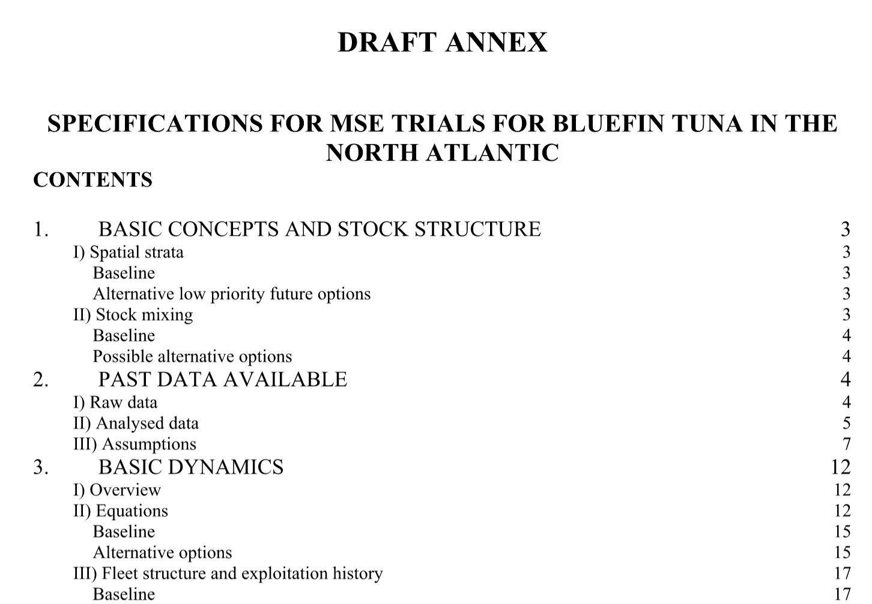

The latest version of the MSE [Trial Specifications document](https://drive.google.com/open?id=1jwOmxgh8DQYeNaQ2eRalPrVF4luV97i2):

## Appendix 2: Meta Database

The [meta-data base](https://drive.google.com/open?id=140HrddEWU_MFHhxizVtaO_uRs48tzPrEgbDMwudl_1M) has been updated (v2.0) to reflect the data that are currently available and those that were used in the fitting of the 36 reference and 4 robustness operating models.

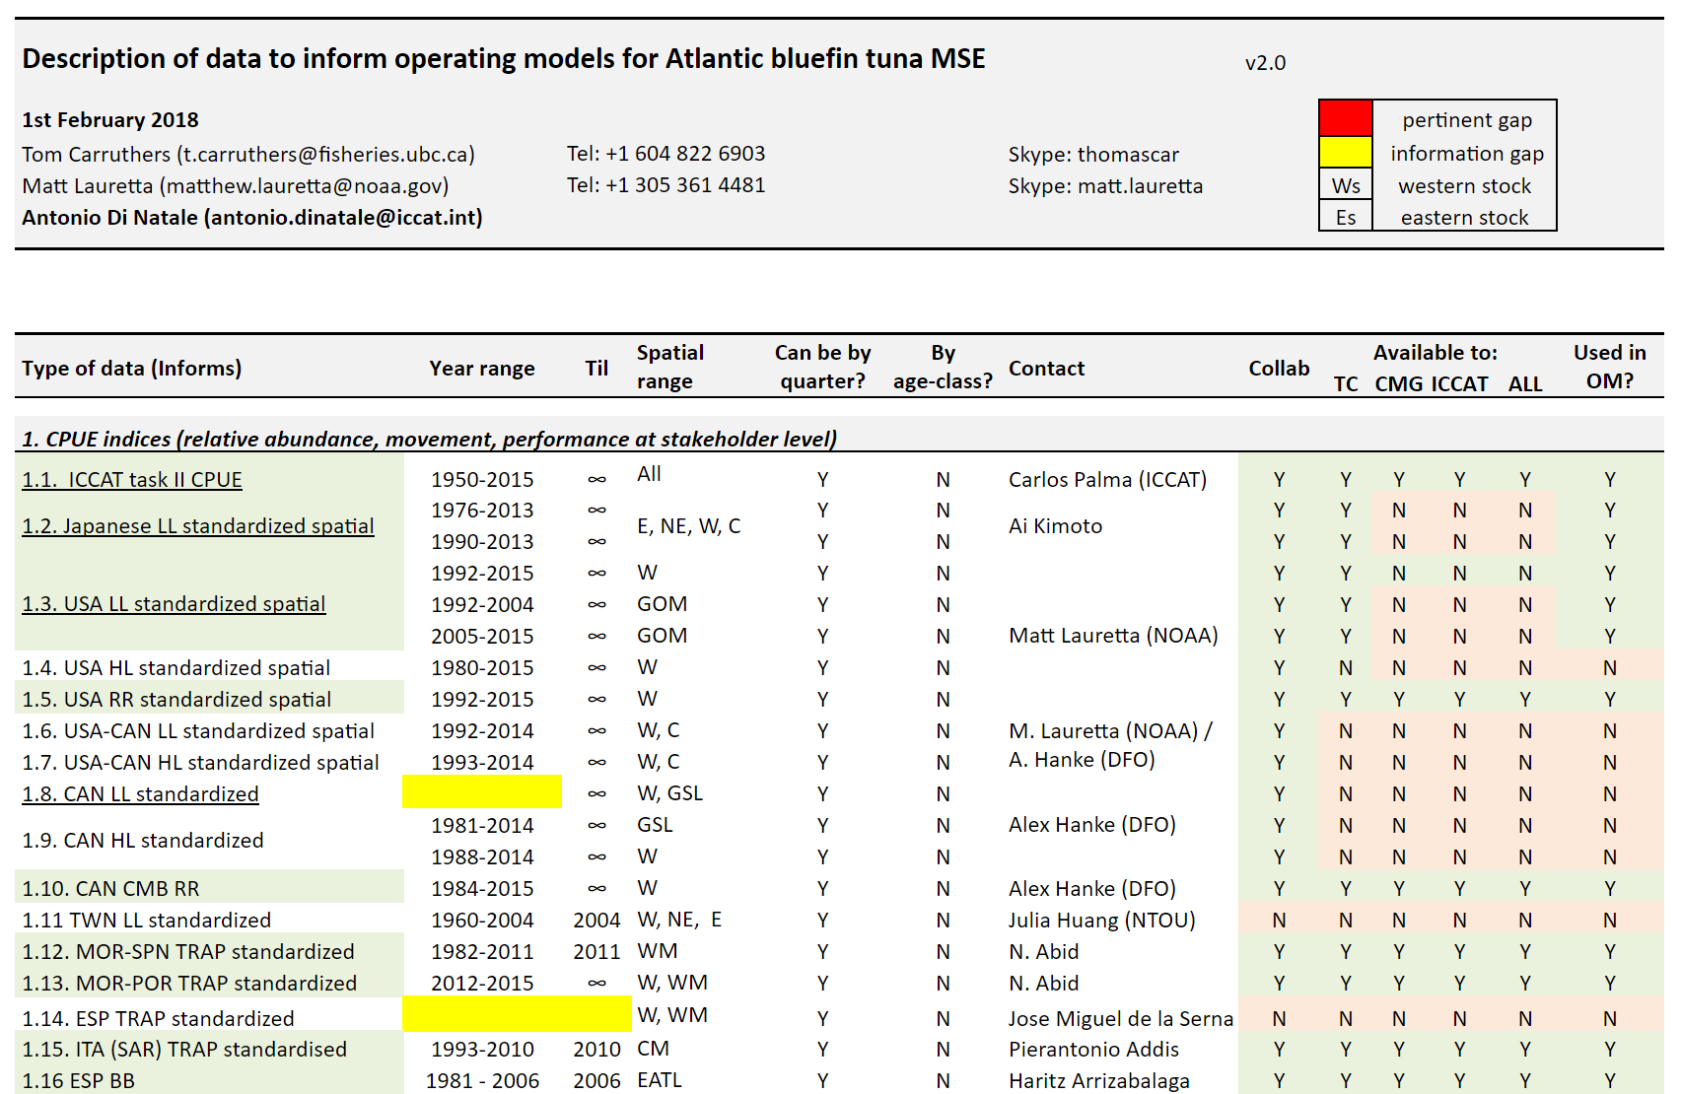

## Appendix 3. SCRS papers.

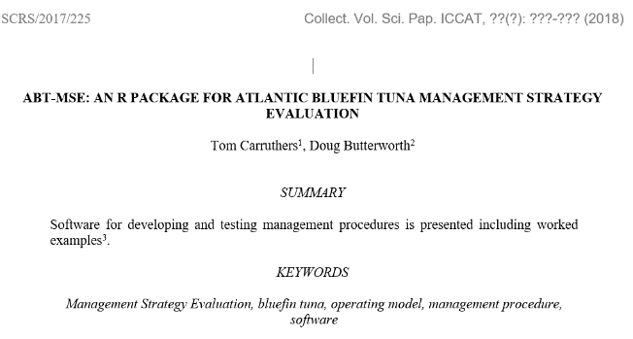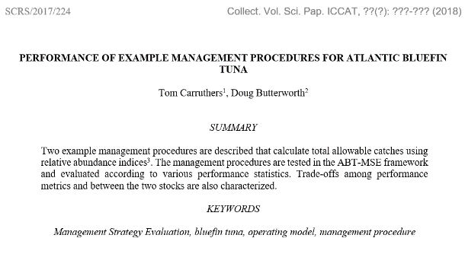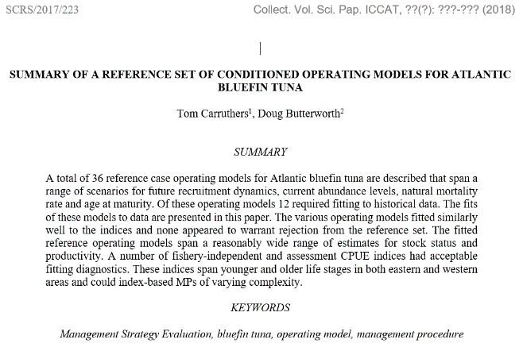

Three SCRS papers were submitted to Redbooks detailing the fits of the reference operating models ([SCRS/2017/223](https://drive.google.com/open?id=1oJmXDD6tRKbEI4DwZnsLbFIAcq1EfiPt)), an example design and testing of a simple management procedure ([SCRS/2017/224](https://drive.google.com/open?id=1gauaI74rowuzY3pAE-qFFlWQuY9wElPI)) and an overview and introduction to the R ABT-MSE package ([SCRS/2017/225](https://drive.google.com/open?id=1IBcZhxNJXwSKkmEoAFoGrj7BhzilNt81))

## Appendix 4: Complete R package for MP testing

## 

All operating models and existing MPs were compiled into a single [R package](https://drive.google.com/open?id=1eJQ_DcZcceYBBJAVNzqkLFxf4VProdZo) complete with live supporting documentation for every object and function.

## Appendix 5: Standardized operating model reporting

In order to rapidly evaluate the fit of operating models to data a [standardized operating model report](https://drive.google.com/open?id=1ppVm2mTsWjZsqtrl-RFQILsmO_OPNpJ0) was developed and refined (an automatic, one-click product) following feedback from the Core Modelling Group.

To compare multiple operating models simultaneously, a [summary report](https://drive.google.com/open?id=1HCzvlkzVStkHZL-As7AOQgYHuQl3-2-C) was also developed.

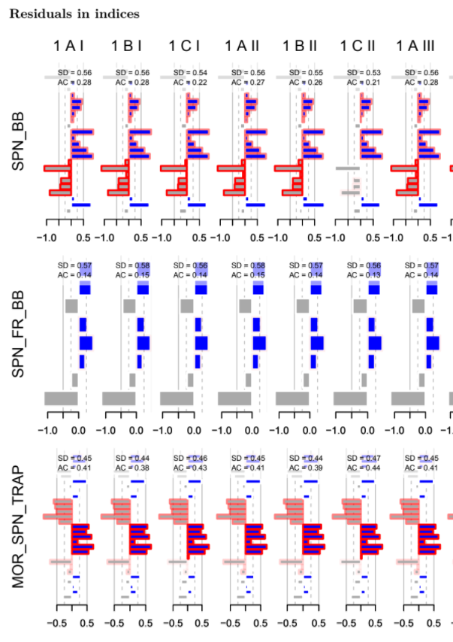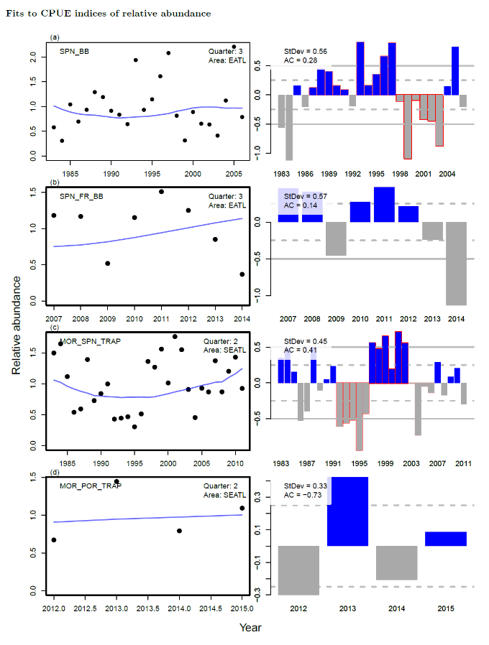

## Appendix 6: Draft peer-review paper on a Multi-stock, Multi-fleet, Multi-area MP

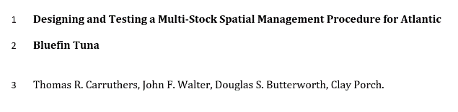

A prospective MP for Atlantic bluefin may have to react to multiple indices with varying lags-to-vulnerable biomass located in spatially distinct areas.

A methodology has been identified (and described in a [draft paper](https://drive.google.com/open?id=1gTsFebF_6jOSfQpsQSvWViVPy0tptHsc)) that could synthesize these data into a single MP providing recommendations simultaneously for both East and West areas.

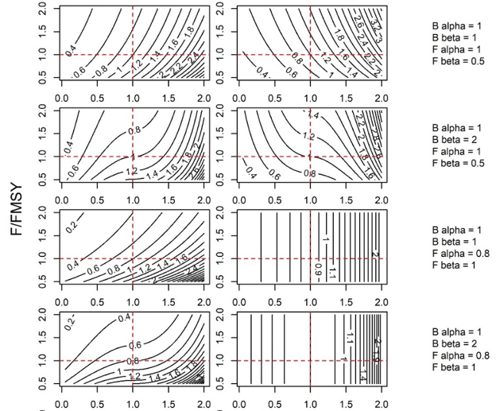

## Appendix 7: Updated M3 user guide

The various requirements of the reference and robustness operating models required modifications to the ADMB M3 model, in particular input file format to accommodate new priors for changes in spawning biomass, relative spawning stock size among East/West areas and stock mixing rates.

The [M3 users guide](https://drive.google.com/open?id=1GwBgtHzPsk4uZVO5wPri8jiPVc-YgPlF) (v1.7) was updated to reflect these changes.

## Appendix 8: R package user guide

The user guide explains the design of the ABT MSE and provides worked examples of the R package functions. The user guide demonstrates the 7 steps of MSE covering custom management procedures, performance metrics and operating models. The user guide is accessible from [here](https://drive.google.com/open?id=0B0HYOP0BN5RPV1BXOGk0cEwyTGM).

## Appendix 9: Software design documents

Following updates to the R package the [Software Design Document for the R Package](https://drive.google.com/open?id=1OcadeChBHx3SFouqayIBg6NuzgMSkwSR) was updated to reflect new priorities and considerations for future phases with an emphasis on MP development.

1. [bluemattersci@gmail.com](mailto:bluemattersci@gmail.com) 2150 Bridgman Ave, North Vancouver, Canada. +1 604 822-6903